Category Overview
2.11.58AM
May 13, 2021
Unnamed Project
Time Units:
Replications:
500
Hours
Values Across All Replications
Key Performance Indicators
Average
System
Number Out
3
Model Filename:
Page
of
1
4
D:\A_Sem_1\Simulation\Final Project\Simulation_Final_Project_Inventory_Management

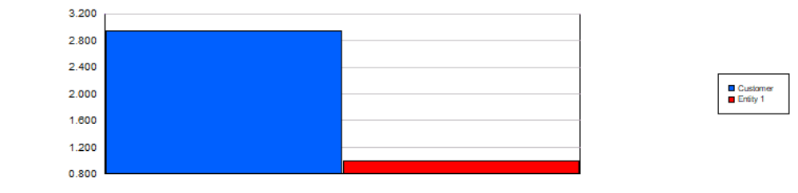
Category Overview
2.11.58AM
May 13, 2021
Unnamed Project
Time Units:
Replications:
500
Hours
Values Across All Replications
Entity
Time
VA Time
Maximum
Average
Minimum
Average
Half Width
Average
Minimum
Value
Maximum
Value
0.00
Customer
< 0.00
0.00
0.00
0.00
0.00
NVA Time
Maximum
Average
Minimum
Average
Half Width
Average
Minimum
Value
Maximum
Value
0.00
Customer
< 0.00
0.00
0.00
0.00
0.00
Wait Time
Maximum
Average
Minimum
Average
Half Width
Average
Minimum
Value
Maximum
Value
0.00
Customer
< 0.00
0.00
0.00
0.00
0.00
Transfer Time
Maximum
Average
Minimum
Average
Half Width
Average
Minimum
Value
Maximum
Value
0.00
Customer
< 0.00
0.00
0.00
0.00
0.00
Other Time
Maximum
Average
Minimum
Average
Half Width
Average
Minimum
Value
Maximum
Value
0.00
Customer
< 0.00
0.00
0.00
0.00
0.00
Total Time
Maximum
Average
Minimum
Average
Half Width
Average
Minimum
Value
Maximum
Value
0.00
Customer
< 0.00
0.00
0.00
0.00
0.00
Other
Number In
Maximum
Average
Minimum
Average
Half Width
Average
Customer
0.04
2.9500
4.0000
2.0000
Entity 1
0.00
1.0000
1.0000
1.0000
Model Filename:
Page
of
2
4
D:\A_Sem_1\Simulation\Final Project\Simulation_Final_Project_Inventory_Management

Category Overview
2.11.58AM
May 13, 2021
Unnamed Project
Time Units:
Replications:
500
Hours
Values Across All Replications
Entity
Other
Number Out
Maximum
Average
Minimum
Average
Half Width
Average
Customer
0.04
2.9500
4.0000
2.0000
Entity 1
0.00
0.00
0.00
0.00
WIP
Maximum
Average
Minimum
Average
Half Width
Average
Minimum
Value
Maximum
Value
0.00
Customer
< 0.00
0.00
0.00
0.00
1.0000
1.0000
Entity 1
< 0.00
1.0000
1.0000
0.00
1.0000
Queue
Time
Waiting Time
Maximum
Average
Minimum
Average
Half Width
Average
Minimum
Value
Maximum
Value
0.00
Manufacturing.Queue
< 0.00
0.00
0.00
0.00
0.00
0.1141
Shall We Produce?.Queue
< 0.10
0.00
11.6798
0.00
11.6798
Other
Number Waiting
Maximum
Average
Minimum
Average
Half Width
Average
Minimum
Value
Maximum
Value
0.00
Manufacturing.Queue
< 0.00
0.00
0.00
0.00
0.00
0.9995
Shall We Produce?.Queue
< 0.00
0.9097
1.0000
0.00
1.0000
Model Filename:
Page
of
3
4
D:\A_Sem_1\Simulation\Final Project\Simulation_Final_Project_Inventory_Management

Category Overview
2.11.58AM
May 13, 2021
Unnamed Project
Time Units:
Replications:
500
Hours
Values Across All Replications
Resource
Usage
Instantaneous Utilization
Maximum
Average
Minimum
Average
Half Width
Average
Minimum
Value
Maximum
Value
0.00049451
Manufacturing Cell
< 0.00
0.00
0.0903
0.00
1.0000
Number Busy
Maximum
Average
Minimum
Average
Half Width
Average
Minimum
Value
Maximum
Value
0.00049451
Manufacturing Cell
< 0.00
0.00
0.0903
0.00
1.0000
Number Scheduled
Maximum
Average
Minimum
Average
Half Width
Average
Minimum
Value
Maximum
Value
1.0000
Manufacturing Cell
< 0.00
1.0000
1.0000
1.0000
1.0000
Scheduled Utilization
Maximum
Average
Minimum
Average
Half Width
Average
Manufacturing Cell
0.00
0.00049451
0.0903
0.00
Total Number Seized
Maximum
Average
Minimum
Average
Half Width
Average
Manufacturing Cell
0.03
0.02800000
5.0000
0.00
User Specified
Counter
Count
Maximum
Average
Minimum
Average
Half Width
Average
0.00
Counter 1
< 0.00
0.00
0.00
Model Filename:
Page
of
4
4
D:\A_Sem_1\Simulation\Final Project\Simulation_Final_Project_Inventory_Management

